

COVID-19
2020 Outbreak Machine Learning Project
By Neliah Goldstein
Bar Illan University | DS20 | 12.11.2025

Introduction
The COVID-19 pandemic took the world by storm, prompting sweeping restrictions, lockdowns, and an unprecedented global response involving public health measures, economic interventions, and vaccine development.
The novel coronavirus, initially designated 2019-nCoV and later named SARS-CoV-2, was first identified in Wuhan, the capital of China’s Hubei province. Early patients developed pneumonia without a clear cause, for which existing vaccines and treatments were ineffective. Evidence soon confirmed human-to-human transmission, and by mid-January 2020, the rate of infection began to escalate rapidly. As of 22 January 2020, approximately 555 cases had been confirmed globally. By the end of July 2020, that number had surged to over 16 million worldwide, reshaping public health systems, economies, and daily life across the globe.
Yet, in the early months of 2020, the pace and pattern of the disease’s spread varied greatly across regions. Understanding the factors that contributed to this divergence remains critical for both retrospective analysis and future preparedness.
This project attempts to do just that by applying machine learning methods to early outbreak data in order to model and predict daily COVID-19 mortality rates. By integrating epidemiological indicators with variables such as government policy responses, quarantine measures, healthcare expenditure, geographic characteristics, and demographic profiles, the study seeks to identify the drivers most strongly associated with mortality outcomes during the first half of 2020.
The findings aim to provide a data-driven understanding of how policy, health infrastructure, and population dynamics influenced the trajectory of the pandemic and to demonstrate the potential of machine learning as a tool for early outbreak assessment and intervention planning.

Link to Github: https://github.com/neliahg/ds20-covid-19

Data Sources
The initial COVID-19 outbreak dataset obtained from Kaggle served as the foundation for this project. However, it soon became evident that much of the content was derivative, or lacked the granularity required for the intended analysis. To ensure data reliability and comprehensiveness, two additional primary sources were incorporated:
- Our World in Data (OWID) is an open-access research platform that compiles and standardizes global statistics from verified institutions such as the World Health Organization (WHO) and the European Centre for Disease Prevention and Control (ECDC). The OWID COVID-19 dataset provides detailed pandemic-related indicators, including testing rates, government responses, and behavioral mobility trends, making it indispensable for capturing the evolving dynamics of the outbreak.
- The World Bank Open Data repository was used to supplement this information with extensive demographic, economic, and healthcare-related variables. These include population size and density, GDP per capita, healthcare expenditure, and age distribution, among others. Such variables were crucial for contextualizing the pandemic’s impact and for enabling the machine learning models to account for underlying socio-economic and structural differences between countries.
Together, these datasets provided a robust foundation for exploring both epidemiological and contextual factors influencing the spread and severity of COVID-19 across regions.

Source | Files | Description
Kaggle Covid-19 Dataset | covid_19_clean_complete.csv  day_wise.csv  worldometer_data.csv | Daily global pandemic statistics at country level, including confirmed, active, recovered, and death counts, as well as derived features (growth rates, mortality ratios, and recovery rates). Serves as the foundation for temporal trend analysis.
Our World in Data (OWID) | google_mobility.csv  gov_policy.csv  tracking_r.csv | Supplementary behavioral and policy datasets providing information on government response measures, human mobility trends, and effective transmission rate (R). Used to analyze the impact of policy and social behavior on viral spread dynamics.
The World Bank Open Database | worldbank_gdp.csv  worldbank_healthcare_percent.csv  worldbank_old_ratio.csv  worldbank_population.csv  worldbank_pop_density.csv  worldbank_smokers.csv  worldbank_young_ratio.csv | Socioeconomic and demographic indicators including GDP, healthcare expenditure, population density, and age group proportions. Used to establish correlations between demographic structure, economic strength, and pandemic outcomes.

Scope & Timeframe
Although a global analysis of the COVID-19 pandemic was initially considered, the heterogeneity of data collection standards and the complexity of integrating multiple regional reporting systems rendered such an approach impractical within the project’s timeframe. Consequently, the study focuses on the World Health Organization (WHO) European Region -- a classification determined by administrative jurisdiction rather than strict geographical boundaries. This region includes countries situated primarily in Europe and parts of Western and Central Asia, for which the WHO Regional Office for Europe oversees surveillance and data management.
Several territories were excluded to preserve data consistency and analytical integrity. These include remote or overseas territories (e.g., Greenland, Guadeloupe, Réunion, and the Falkland Islands) and microstates such as Vatican City, where the availability of comprehensive socio-economic and epidemiological data is limited. Exclusions were based on factors such as geographical isolation, incomplete reporting, and the absence of relevant demographic or policy indicators. By refining the dataset in this manner, the project maintains a coherent analytical scope while ensuring that comparisons among countries remain meaningful and methodologically sound.
The study period spans from January 22, 2020, to July 27, 2020, encompassing the initial phase of the COVID-19 pandemic. This timeframe captures the crucial early months of the global outbreak, during which most countries experienced their first wave of infections and implemented their initial containment and mitigation measures. Focusing on this period allows for the examination of early government responses, testing expansion, and behavioral shifts, before the influence of vaccination campaigns or later pandemic dynamics.

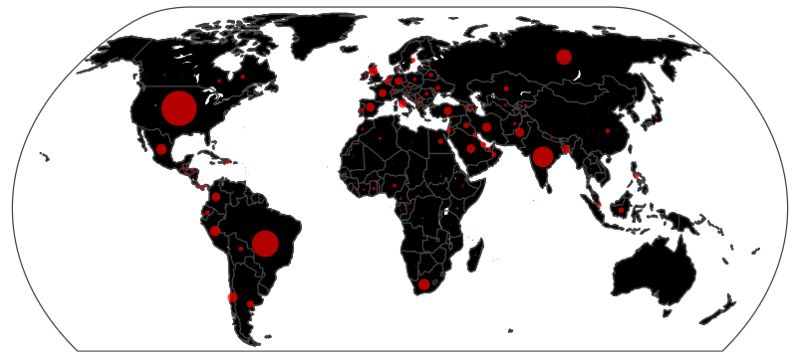
Figure 1. Global distribution of confirmed COVID-19 cases as of July 2020.
The figure illustrates the worldwide spread of COVID-19 during the early phase of the pandemic, highlighting regions of concentrated infection across Europe, Asia, and the Americas. Data represent cumulative confirmed cases reported to the World Health Organization (WHO) by the end of July 2020.
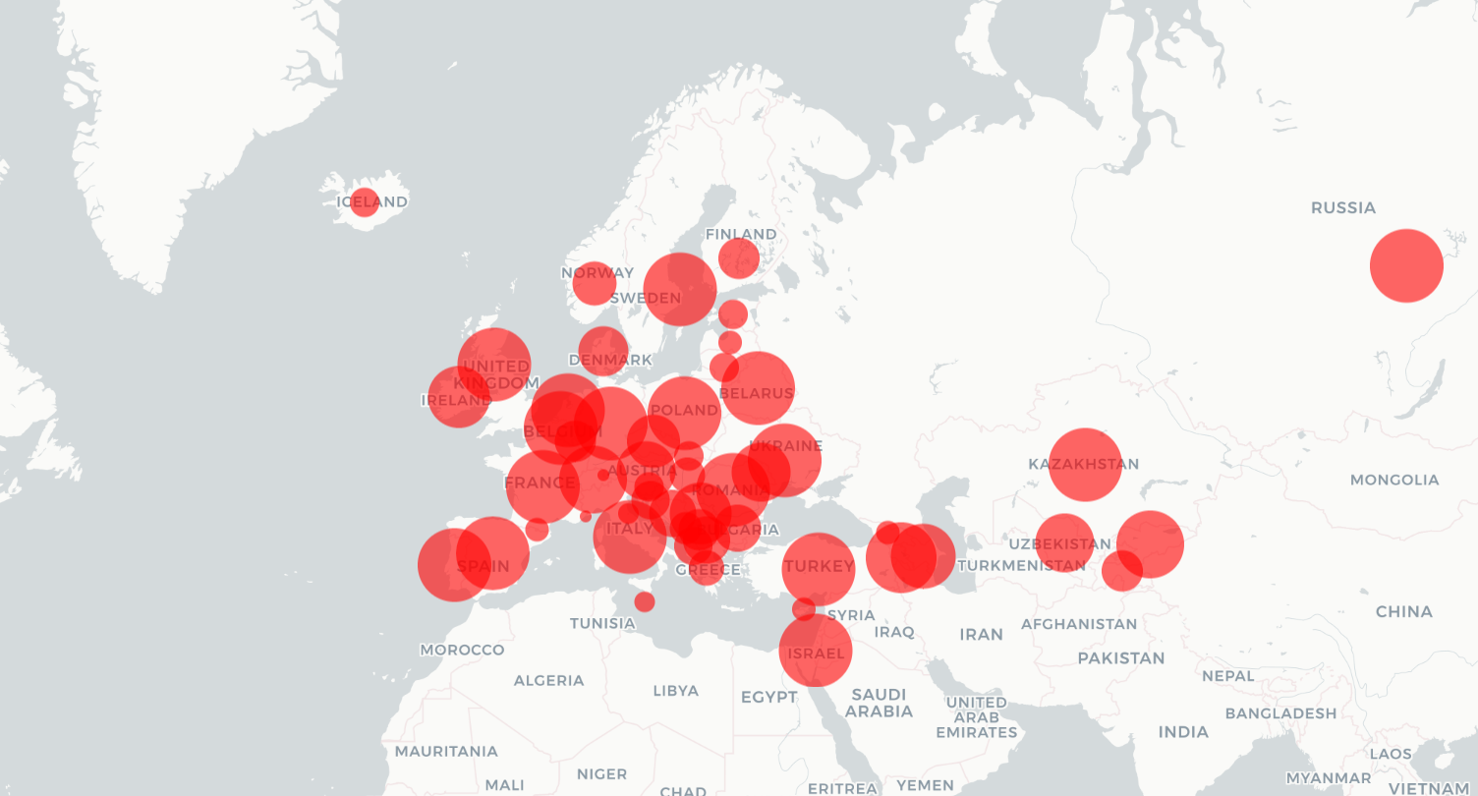

Figure 2. WHO Region Europe: Geographic spread of the COVID-19 pandemic by July 2020.
Each circle represents the magnitude of new active cases per country, scaled relative to outbreak intensity. The figure highlights the uneven distribution of cases across the WHO European Region, with the highest concentrations appearing in Western and Southern Europe by mid-2020.

Notebooks
- 0. Get Pickles
- 1.1. Preparation
- 1.2. Preparation – Continued
- 2. Exploratory Data Analysis (EDA)
- 3. Data Cleansing.ipynb
- 4. Feature Engineering & Selection
- Model Selection & Hypertuning
- Regression Model

1. Preparation

The first and most critical phase of this machine learning project was data preparation, as the accuracy and reliability of the model depend directly on the quality of the input data. This stage involved merging multiple datasets at the country and date level to form a unified analytical framework. Each dataset was carefully aligned to ensure temporal and geographical consistency. Significant effort was devoted to verifying the completeness and validity of the data, cross-referencing figures against multiple authoritative sources to ensure that the final dataset accurately reflected the real-world progression of the pandemic.
1.1. Missing Values
One of the initially identified datasets (Hospitalizations) was of considerable potential importance due to its direct relevance to disease severity and healthcare system burden. However, upon closer inspection, it was found to be largely incomplete, with 70–90% of its entries missing across most columns. Given this extent of missingness, the dataset was excluded entirely from the analysis and does not appear in the final notebooks.
Outside of the hospitalization data, missing values were handled progressively during the data merging and cleaning stages, where possible without requiring specialized imputation methods. In many cases, missing country-level statistics were easily recovered through secondary verification (for example, Kosovo’s population density was obtained via external demographic sources).
More substantial missingness occurred in several key datasets: approximately 50% of testing data, 35% of mobility data, 30% of the reproduction rate (“r”) dataset, and around 5% in the government restriction measures dataset. In some instances, missing entries could be addressed through logical extrapolation rather than statistical imputation. For example, countries where the pandemic had not yet reached (such as Ukraine before late March 2020) had no restrictions in effect, so corresponding features were reasonably set to 0 (indicating no special measures) rather than left as missing. Similarly, Google’s mobility data collection began only in February 2020; therefore, early missing values were treated as baseline mobility levels preceding the introduction of restrictions.
1.2. Missing Values: r-Streaks
The rate of transmission, denoted as R (Effective Reproduction Number), measures how contagious a disease is at a given point in time. It represents the average number of people to whom a single infected individual transmits the virus.
- R > 1 indicates that infections are spreading — each case leads to more than one new case.
- R = 1 signifies a stable outbreak — each infection replaces itself.
- R < 1 suggests a declining outbreak — the spread is slowing.
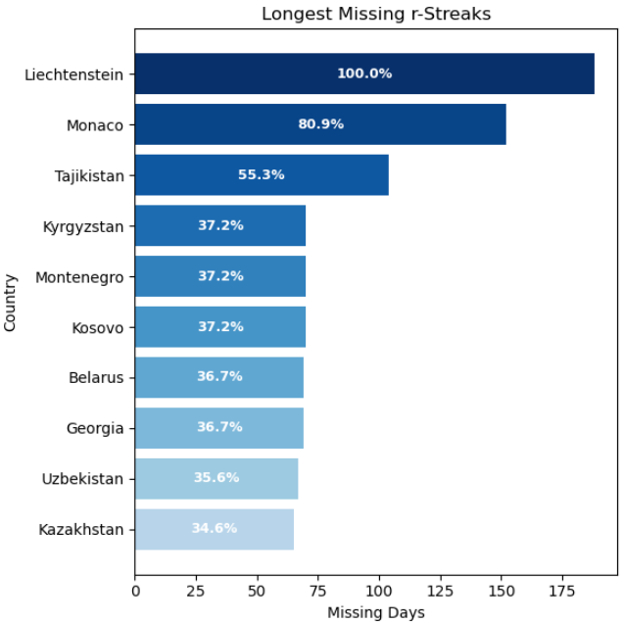
Because of its importance in epidemiological modeling, particular attention was given to the integrity of the R dataset. An additional check was performed to ensure there were no missing values (NaNs) appearing mid-series (i.e., isolated gaps). The analysis revealed that while most countries had complete time series, a few exhibited missing data in contiguous blocks, or “streaks,” often beginning from the first observation date (2020-01-22) and appearing later in the dataset (see Figure x, “Top 10 missing R-streaks across countries”). In one case (Liechtenstein), data for R were missing entirely.
According to the SIR model, the effective reproduction number is linearly related to the growth rate of infections, which can be estimated through a Kalman filter applied to new-case data. Therefore, continuous and accurate reporting is essential. The observed R-streaks, however, largely coincided with the early months of the pandemic, when outbreaks had not yet begun in several countries — a plausible reason for the absence of data. Nonetheless, in certain cases the missing periods were disproportionately long. For instance, Monaco’s first recorded R value appeared roughly 150 days into the pandemic, whereas independent records show that local transmission began closer to day 60. This indicates that at least some of the missing entries were genuine reporting gaps rather than an absence of infection.
To verify this, countries with missing R values were re-examined for periods when active cases exceeded 100, provided there had been at least one active case in the preceding week. In such instances, R could have been reasonably estimated. Only 41 rows met these criteria and were updated manually, confirming that the vast majority of missing values were legitimate.
For modeling purposes, these remaining missing R values were retained but replaced with 0 to ensure compatibility with machine-learning algorithms. A binary flag column (r_nan_flag) was added to preserve this information and allow the model to account for these synthetic values during comparison and feature evaluation.
1.3. Missing Values: Mobility Data
Beginning in February 2020, when lockdown measures were first implemented globally, Google initiated the publication of Community Mobility Reports, which tracked changes in movement patterns relative to a pre-pandemic baseline. As with transmission rates, outbreaks and subsequent restrictions did not occur simultaneously across all countries.
To address this temporal inconsistency, the start date of recorded measures for each country was identified, and all preceding dates were assigned a baseline value of 0, representing normal pre-restriction mobility levels. This adjustment substantially reduced missing values in the mobility dataset — from approximately 35% to 20%, with 1,404 rows set to baseline.
The remaining 20% of missing entries originated from countries where Google did not collect mobility data, including Albania, Andorra, Armenia, Azerbaijan, Cyprus, San Marino, Montenegro, Monaco, Uzbekistan, and Kosovo. The absence of these records is primarily attributed to privacy regulations or Google’s own data coverage policies. In a few cases, countries reported only partial mobility indicators (for example, “Workplaces” and “Transit Stations”), while others remained unreported.
To complete the dataset, a K-Nearest Neighbors (KNN) imputation was applied, using all restriction (policy) and mobility-related features, along with the regional classification, to estimate the most probable missing values. Post-imputation validation revealed no substantial deviation in trend continuity or feature behavior, indicating that the imputation was both statistically sound and contextually consistent with the original data.
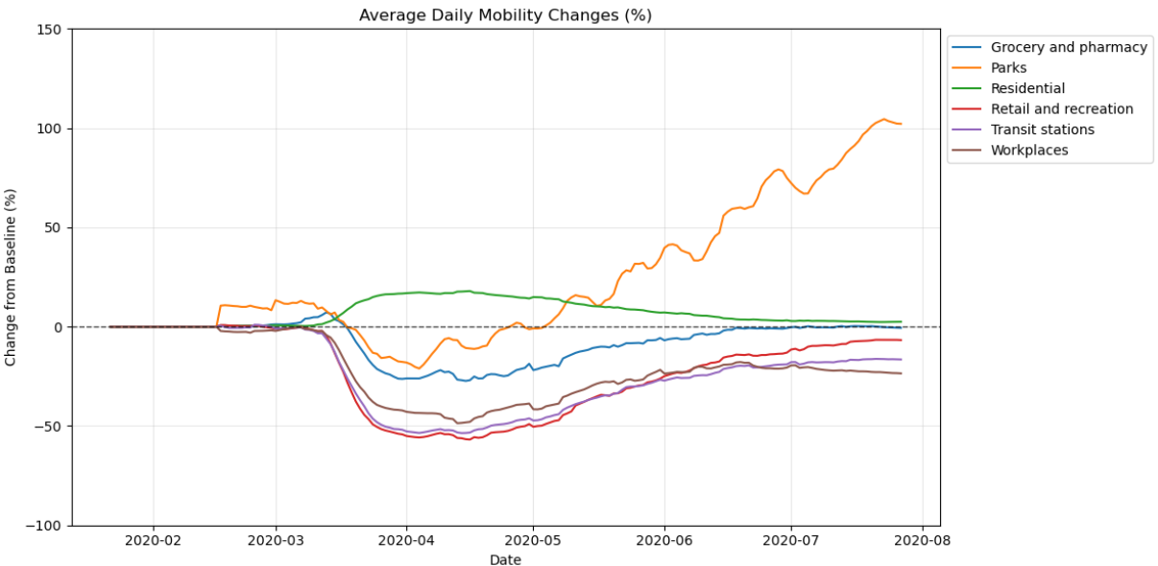

1.4. Missing Values: Testing Data
Approximately 50% of testing data was missing from the dataset, with some countries (Andorra, Azerbaijan, Georgia, Kosovo, Kyrgyzstan, Moldova, Monaco, Montenegro, San Marino, Tajikistan, and Uzbekistan) entirely absent from the original reporting.
The testing data originated from Our World in Data (OWID), which aggregates information from multiple national sources. While Worldometer is typically considered the most reliable source for this type of data, no complete archival dataset was available for the 2020 period, and Worldometer itself does not publish historical data. However, a partial snapshot from late July 2020 was obtained and used to extrapolate “total tests” for missing countries, reducing the missing rate for that feature to approximately 39%.
Analysis showed that the missingness pattern was not random but rather accumulative—countries with later outbreaks naturally lacked early testing data. For such cases, it was reasonable to infer that testing levels were effectively zero prior to the first confirmed case. Therefore, dates preceding the local outbreak onset were assigned a value of zero, further lowering the total number of missing entries.
For the remaining gaps, several imputation methods were evaluated. Both MICE and KNN imputations introduced erratic fluctuations that distorted the natural growth trends visible in verified data. A visual review of country-level trends indicated that missing testing data followed a consistent logarithmic growth pattern, even when not recorded daily.
Consequently, for countries with less than 50% missing data, missing values were filled using simple interpolation, preserving the natural progression of testing rates. For countries with greater than 50% missing data, values were extrapolated proportionally from the number of confirmed cases, which produced smoother and more realistic trajectories than any of the statistical imputation techniques tested.

Before:
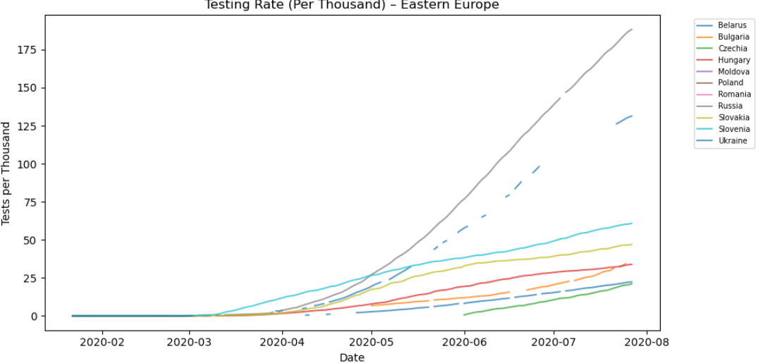
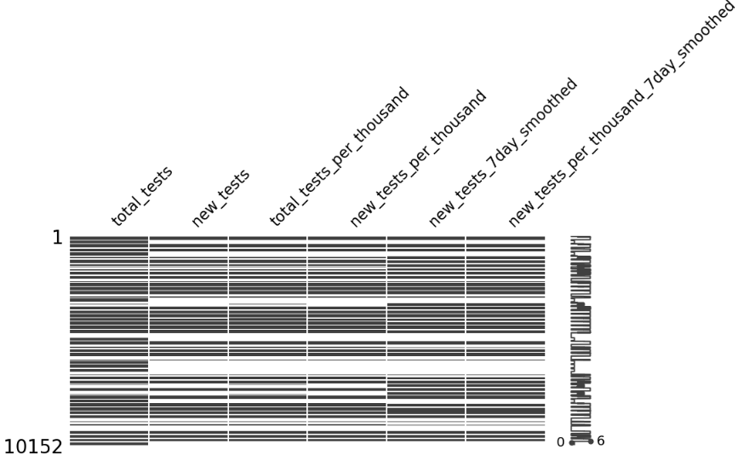

After:
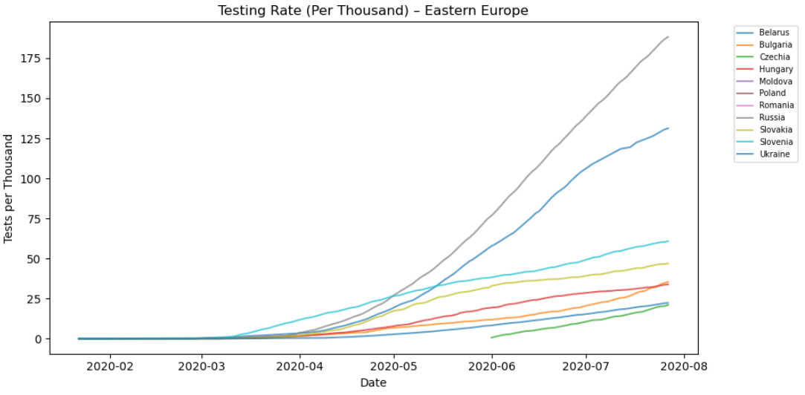
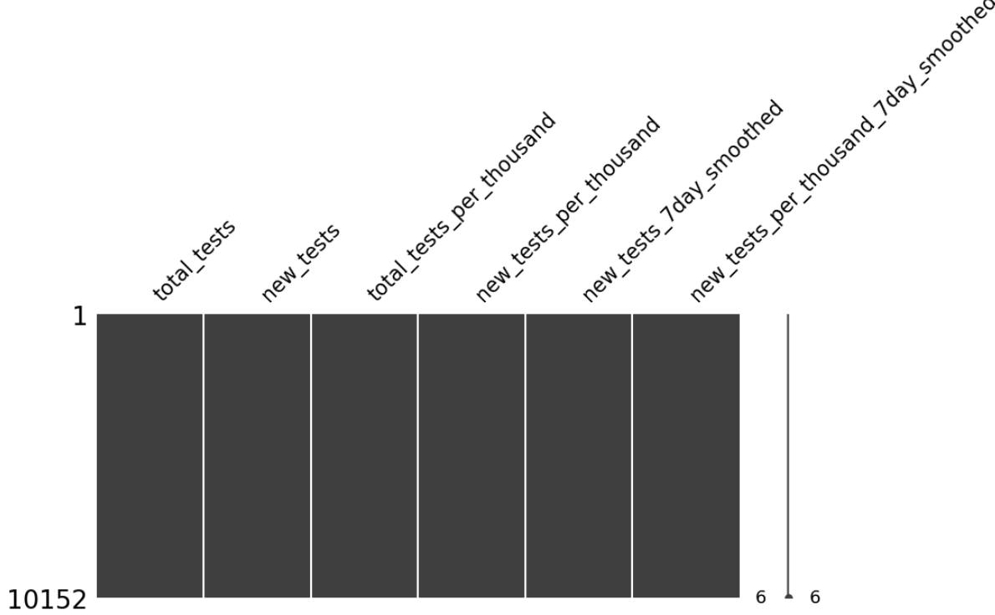

1.5. Outliers
Managing outliers in pandemic data presents unique difficulties due to the inherently non-stationary and cumulative nature of the data. Unlike static datasets where deviations are easily defined, COVID-19 indicators such as confirmed cases, deaths, and tests grow over time—often exponentially during early outbreak phases and unevenly across countries. This makes conventional outlier detection methods (e.g., z-scores or IQR thresholds) ineffective, as they flag normal surges in infection or reporting delays as “anomalies.”
Therefore, handling outliers in this context required trend-aware approaches, such as analysing growth rates rather than absolute values. To reduce distortion from differences in scale, the model utilizes per-100 cases variables to normalize comparisons across countries. Population effects were feature-engineered into categorical groupings, while country-specific outliers were addressed logically rather than statistically.
A notable example concerns population density. Russia, with its vast landmass, appears to have an extremely low density compared to other nations; however, most of its population is concentrated in a few urban areas, meaning the true effective density is much higher than raw data implies. Conversely, Monaco’s extremely small territory and high reported density, combined with its very limited population, make it an inverse outlier. Both cases introduce bias that numerical normalization cannot correct; therefore, they were recoded under the category “Unknown” to preserve analytical consistency and prevent skewing model results.
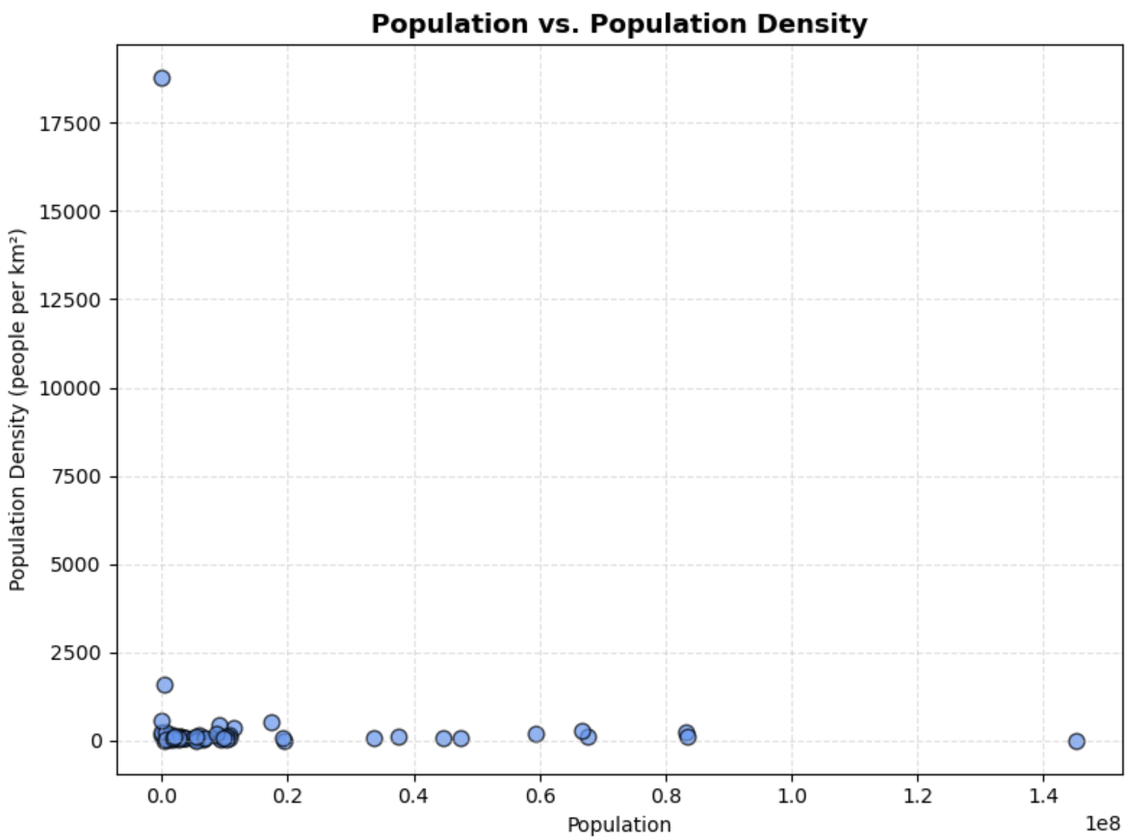

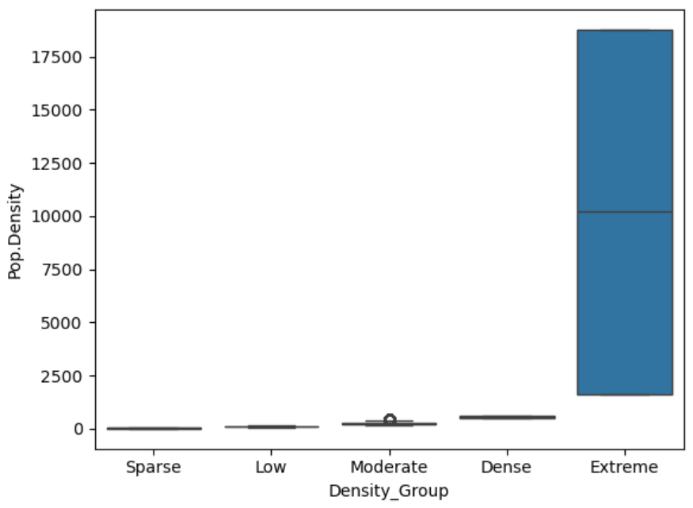
The following boxplot perfectly shows why binning is needed — the “Extreme” group (mostly microstates like Monaco and San Marino) is so disproportionate that it dominates the entire scale.
Changing to reflect as categorical grouping (with later cat encoding) shows the following:

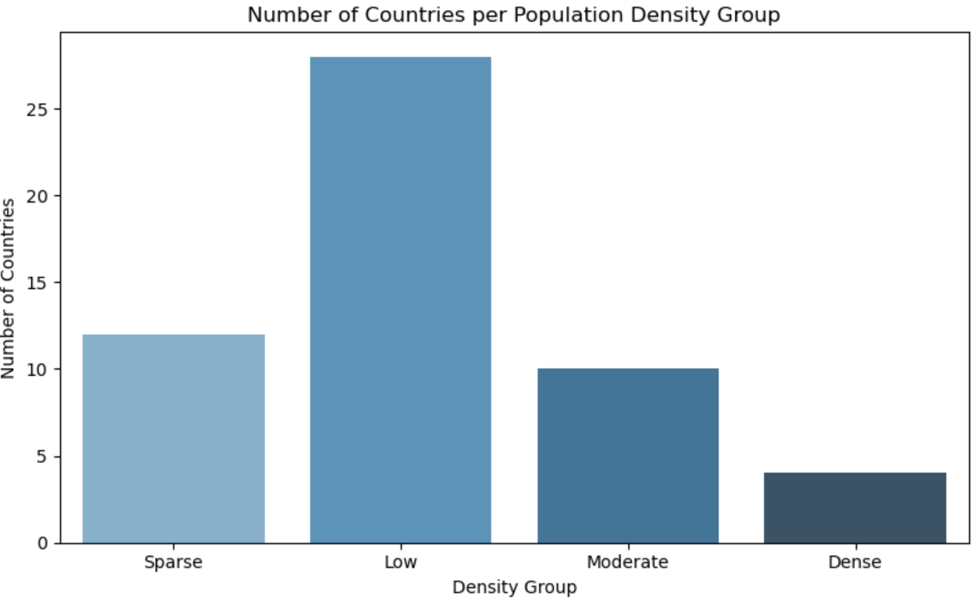

The same is done for population size:
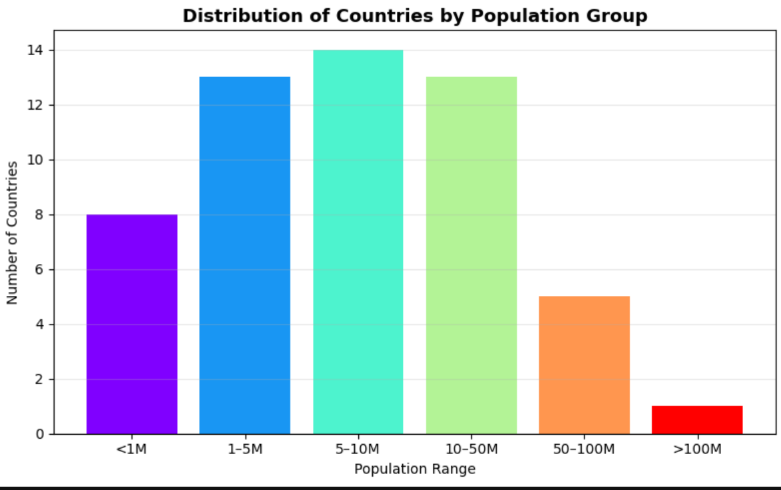

Age distribution likewise displayed some extreme outliers.
Aging demographics:
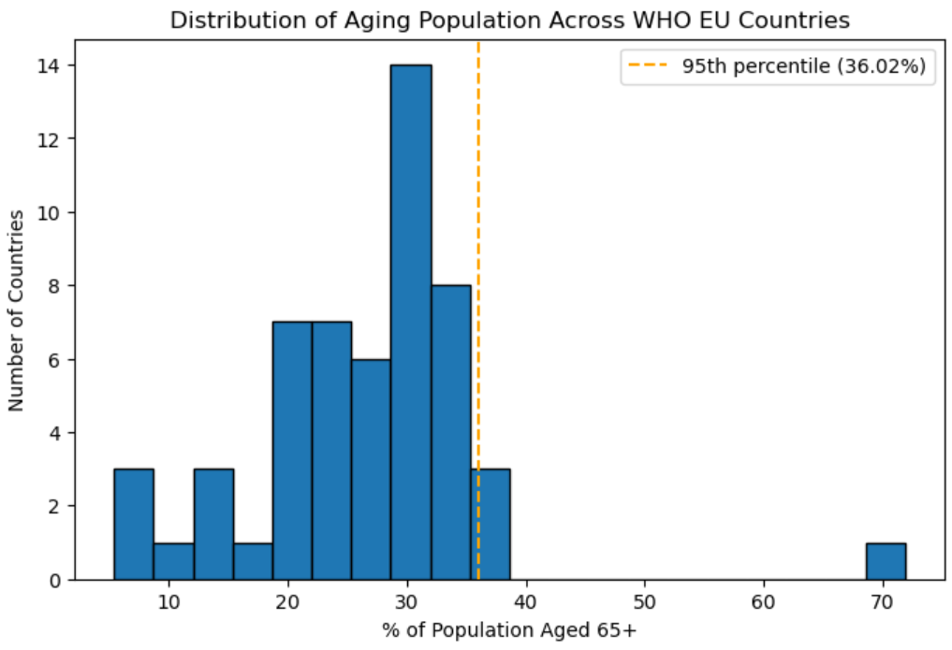

- Monaco is a top 1% aging country with 71.86% of its population aged 65+.
- Italy is a top 1% aging country with 36.65% of its population aged 65+.
- Finland is a top 1% aging country with 36.36% of its population aged 65+.

Monaco initially appeared as having 71.86 % of its population aged 65+, which is statistically implausible when compared to global demographics. Even the world’s oldest countries -- Italy (36.65 %) and Finland (36.36 %) cluster around the mid-30s range.
Monaco’s small population (roughly 40 000 people) and its unusual demographics make it a statistical outlier, due to its population composition (a large share of its residents are wealthy retirees from abroad, but many are not counted as permanent residents) and its status as a microstate. To prevent it from distorting analyses, the value was capped at 36.65 %, consistent with Italy’s verified upper range for aging populations, while retaining all other countries’ observed values.

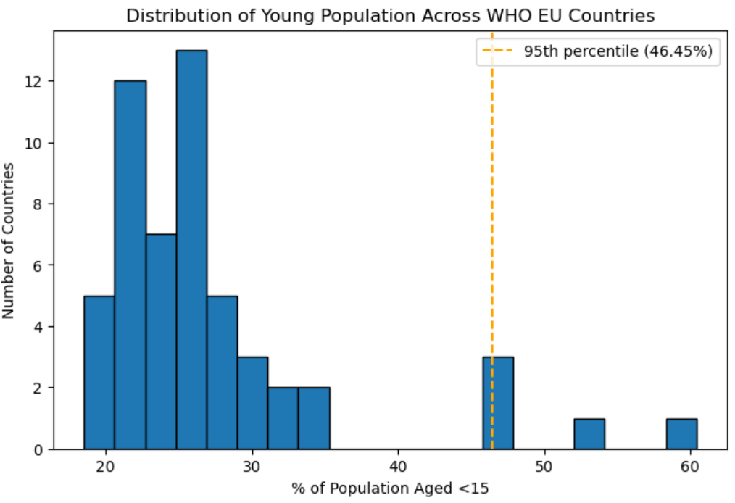

In contrast, Tajikistan, Kyrgyzstan, and Israel genuinely form the top 5 % youngest populations in the WHO EU dataset. Their high under-15 percentages are demographically valid and should be preserved for accurate representation of fertility and population-structure differences. The values align with known regional demographics; they’re not distortions or calculation errors. In this case, capping would remove meaningful variation in the young-population distribution.

2. Exploratory Data Analysis (EDA)

Following data consolidation, exploratory data analysis (EDA) was conducted to better understand the dataset’s structure, internal relationships, and potential biases.
2. 1. AutoViz
Automated visualization tools such as AutoViz were employed to profile numerical and categorical features and to detect anomalies across multiple dimensions. While AutoViz serves primarily as a preliminary inspection tool and lacks the sensitivity required for steadily increasing or time-dependent regression data, it proved valuable in uncovering hidden relationships, identifying outliers, and flagging potential noise within the dataset.
Key observations included:
- Correlation of outbreak state with running days – unsurprising given the rapid early outbreak dynamics.
- Accumulative totals – continuously growing variables dominated the data distribution and risked skewing model learning.
- Monotonic features – variables increasing linearly over time contributed little new information, risking models that learned temporal progression rather than causal relationships.
2.2. Correlations
A comprehensive correlation analysis was conducted to identify hidden relationships and potential feature overlaps (see preliminary feature correlation EDA.xlsx).
Continent encoding (Asia/Europe) showed generally weak correlations with most features, except with demographic structure variables such as population age composition. Further examination will assess how population structure—particularly the proportions of younger and older individuals—affected pandemic dynamics.
The variable % aging.pop displayed a moderate positive correlation with GDP-related metrics (GDP_per_capita, GDP_billions) and negative correlations with % young.pop and % healthcare, reflecting the tendency of wealthier nations to have older populations. GDP_per_capita and % healthcare also showed a moderate positive relationship (r ≈ 0.5–0.6), consistent with greater healthcare investment in developed economies.
As expected, restriction indicators rose concurrently and exhibited strong inter-correlation. They were generally negatively correlated with mobility variables—indicating reduced movement during periods of restriction—with the notable exception of PARKS, which increased during lockdowns as individuals sought outdoor spaces.
Category | Key Relationships | Interpretation
Continent Encoding | Weak correlation with most features; stronger with % young/aging population | Demographic differences between regions explain most variance
Demographics & Economy | % aging.pop ↔ GDP (+); % young.pop ↔ GDP (–); % aging.pop ↔ % healthcare (–) | Wealthier nations have older populations and lower healthcare % share
Economic Indicators | GDP_per_capita ↔ % healthcare (+0.5–0.6) | Higher healthcare investment in developed economies
Restrictions | Strong internal correlation among restriction indicators | Measures implemented simultaneously during outbreak peaks
Mobility | Restrictions ↔ mobility (–); PARKS ↔ restrictions (+) | Movement decreases overall; outdoor mobility rises during lockdowns

2.3. Epidemiological and Socio-Economic Relationships
Strong positive correlations were observed between Confirmed, Active, and Recovered cases, indicating that recoveries scaled proportionally with total confirmed infections. Mortality was generally proportional to total cases.
Moderate correlations were found between epidemiological outcomes and policy measures. Testing and health response variables such as h2_testing_policy and h6m_facial_coverings showed mild positive associations (r ≈ 0.2–0.3) with Confirmed and Deaths, suggesting that stricter policies tended to coincide with higher case volumes. Socio-economic indicators, including % healthcare expenditure (r ≈ 0.3) and GDP_per_capita (r ≈ 0.6 with region encoding), also demonstrated mild to moderate correlations with health outcomes, reflecting variations in infrastructure and data quality across countries.
Demographic variables such as population density, % aging population, and % smoking exhibited weak or negligible linear relationships with case and mortality counts, indicating that within the WHO European Region these factors did not show clear linear effects during the observed period.

Regional analysis (Figure X) highlighted clear demographic and economic disparities. Western and Southern Europe displayed the highest mortality rates per 100 confirmed cases (5.25 and 4.16 respectively), coupled with high GDP per capita and older populations. In contrast, Central Asia and the Caucasus recorded markedly lower fatality rates (0.56 and 0.97) and lower healthcare expenditure.
 | Dead/100 Cases | % aging.pop | % young.pop | Pop.Density | GDP_per_capita | % healthcare
Dead/100 Cases | 100% | 81% | -74% | 46% | 85% | 81%
% aging.pop | 81% | 100% | -95% | 48% | 62% | 91%
% young.pop | -74% | -95% | 100% | -38% | -49% | -77%
Pop.Density | 46% | 48% | -38% | 100% | 35% | 30%
GDP_per_capita | 85% | 62% | -49% | 35% | 100% | 80%
% healthcare | 81% | 91% | -77% | 30% | 80% | 100%

2.4. Time-Dependent Correlations
In time-dependent systems, correlation alone can give a distorted picture of cause and effect. Actions and outcomes rarely occur simultaneously, and there is typically a lag between an intervention and its measurable impact.
For example, a policy restriction, a marketing campaign, or a treatment may take days or weeks before measurable results appear. During that delay, both variables can move in similar or even opposite directions for reasons unrelated to each other. As a result, a simple correlation may suggest a relationship that is weaker, stronger, or reversed compared to the true underlying effect.
This is testing with “stay at home” restriction. A lag of 14 days was introduced and the correlation with ‘New Active’ (previously weak) was checked once more.
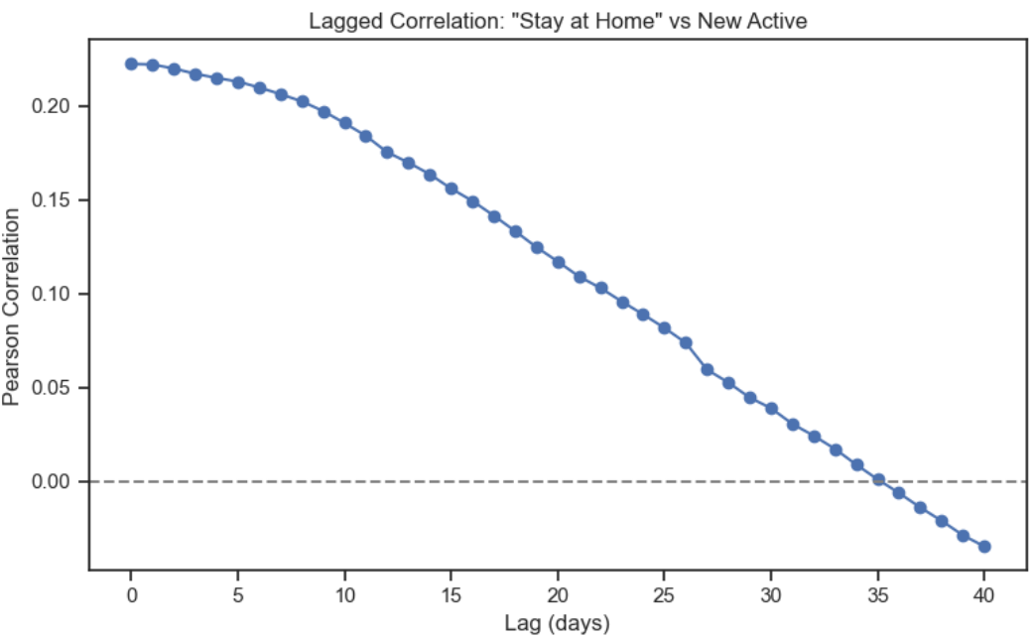
The lag correlation curve demonstrated a steady decline in correlation, from +0.22 at zero lag to near 0 after 35–40 days. This pattern highlights the inherent delay between policy implementation and epidemiological response: restrictions initially rise with case counts but begin to reduce transmission weeks later.
In summary, correlation captures co-movement, not causality. When time delays are present, interpreting correlation without considering lag can lead to misleading conclusions about the true drivers of change.

3. Data Cleanse

3.1. NaN Handling
All missing values addressed under data preparation!
3.2. Remove redundant or perfectly correlated features
- All ‘flag’ features (noting where missing data was handles) removed as to not add noise to the model
- All continuous WW features were removed as it highly correlates (1-1) with ‘Running days’ feature.
- All accumulative features removed and replaced with feature/100 cases to normalize the differences between countries.
3.3. Reducing large categories
For interpretability, WW.No. of countries (represents the number of affected countries) was converted to a categorical “Pandemic Status” to reduce the number of categories.
Range | Category Label | Interpretation
0–25 | Localized Outbreak | Early or isolated spread
26–75 | Regional Spread | Multiple regions affected
76–125 | Global Expansion | Widespread international transmission
126–175 | Pandemic Peak | Near-global infection levels
176–187 | Global Saturation | Practically all countries affected

3.4. Name changes for better readability
Original Code | New Name
c1m_school_closing | School_Closing
c2m_workplace_closing | Workplace_Closing
c3m_cancel_public_events | Public_Events_Canceled
c4m_restrictions_on_gatherings | Gathering_Restrictions
c5m_close_public_transport | Public_Transport_Closed
c6m_stay_at_home_requirements | Stay_at_Home
c7m_restrictions_on_internal_movement | Internal_Movement_Restrictions
c8ev_international_travel_controls | International_Travel_Controls
e1_income_support | Income_Support
e2_debt_contract_relief | Debt_Relief
h1_public_information_campaigns | Public_Info_Campaigns
h2_testing_policy | Testing_Policy
h3_contact_tracing | Contact_Tracing
h6m_facial_coverings | Mask_Mandate

3.4. Assessing highly skewed continuous values
Column: GDP_billions (total GDP by country) raw values were highly right-skewed (ranging from ≈1 - 3940 billion). This large spread caused disproportionate influence from a few high-GDP countries.
The decision was to apply a logarithmic transformation (log_GDP_billions = log(GDP_billions + 1)) to compress extreme values and make the variable more normally distributed. This preserves relative differences while reducing skew, improving correlation and model stability.
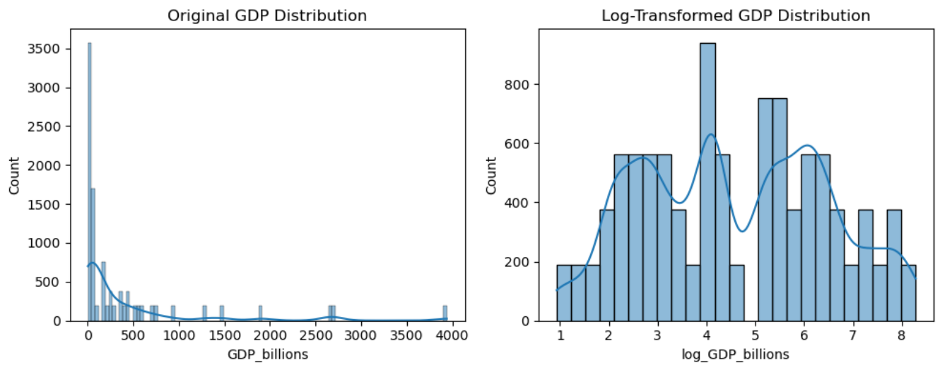

The next step was to compare GDP measures:
- log_GDP_billions - total economic scale
- GDP_per_capita - economic prosperity per person
Correlation analysis showed r ≈ 0.05, meaning they are statistically independent and represent different aspects of the economy. Therefore, it was decided to keep both, as they provide complementary perspectives without redundancy.
3.5. Leaky features
Some features “spoil the ending” – they contain information that too closely relates to the target variable (New Deaths). Variables such as ‘Deaths’, and ‘Deaths/100 Cases’ were therefore excluded from the training data to ensure that the model’s predictions relied on independent, explanatory variables rather than outcome proxies.

4. Feature Engineering & Selection

4.1. Lagged Features
As previously noted, some features are time-sensitive and do not correlate strongly with outcomes unless the inherent delay between cause and effect is accounted for. For example, in the initial correlation analysis, policy measures such as mask mandates or workplace closures showed weak or even positive correlations with new active cases. This occurs because these interventions are often implemented reactively, and their impact becomes visible only after a delay. Once this response lag is introduced, the expected inverse relationship—restrictions leading to a subsequent decline in new cases—becomes much clearer.

To better capture this effect, new lagged features were added for both policy measures and mobility indicators. Each feature was shifted by 14 days (_lag14) and 30 days (_lag30) to represent short- and medium-term impacts, with missing values at the data boundaries capped using the last available observation. This adjustment allows the model to recognize delayed behavioral and policy effects more accurately, aligning the predictors with the true temporal dynamics of the outbreak.
Policy | Immediate Corr (w/ New Deaths) | Lag 30 Corr | Interpretation
Workplace Closing | 0.255 | 0.075 | Effect weakens sharply → restrictions preceded later stabilization.
Internal Movement Restrictions | 0.220 | 0.076 | Drops → consistent with delayed effect on mortality.
Stay-at-Home | 0.211 | 0.074 | Similar pattern; later outcomes flatten.
School Closing | 0.192 | –0.025 | Slight sign flip → possibly protective after a delay.
Gathering Restrictions | 0.186 | 0.048 | Minor positive → sustained but small impact.
Public Events Canceled | 0.172 | –0.058 | Reversal → effect appears delayed and beneficial.
Public Transport Closed | 0.093 | –0.025 | Negligible immediate; mild delayed reduction.
International Travel Controls | 0.040 | –0.064 | Early travel controls saturate quickly → delayed inverse.
Mask Mandate | 0.042 | –0.034 | Weak immediate; small negative lag correlation → gradual effect.

4.2. Socio-Economical Feature
As previously observed, there is a clear correlation between wealth and mortality rate. However, correlation does not imply causation. While wealth consistently receives a high feature importance score in our models, it clearly doesn’t capture the full picture. To address this, I’ve combined economic and demographic indicators into a composite feature, which appears to provide a more balanced and meaningful representation — and is showing strong potential at this stage.
4.3. GeoCluster
Groups countries by geographic proximity and shared regional traits, capturing spatial patterns such as policy diffusion, cultural similarity, and cross-border effects. This helps the model recognize regional trends that individual country variables may miss.
4.4. Feature Selection
All engineered features were selected by at least two of the four tested models (Lasso, Ridge, Random Forest, Gradient Boosting), confirming that each variable provides meaningful explanatory power for New Deaths. The broad agreement across both linear and non-linear models suggests that the final dataset is already well-curated, with no redundant or purely noise-driven predictors. Subsequent modeling will therefore retain all features, while later stages will be used to quantify relative influence.

4.5. Lag Comparison Summary
When reviewing our previous lag analysis, we found that nearly all features showed a stronger impact at the 30-day lag, suggesting that policy and behavioral effects take longer to materialize.
The only exception was Retail_and_recreation, which demonstrated a faster response pattern, indicating a more immediate effect — we’ll keep this one.
Feature Base | lag14 | lag30 | Higher
Gathering_Restrictions | 1 | 1 | Equal
Grocery_and_pharmacy | 3 | 4 | lag30
Internal_Movement_Restrictions | 3 | 3 | Equal
International_Travel_Controls | 2 | 3 | lag30
Mask_Mandate | 2 | 2 | Equal
Parks | 4 | 4 | Equal
Public_Events_Canceled | 2 | 2 | Equal
Public_Transport_Closed | 1 | 3 | lag30
Residential | 4 | 4 | Equal
Retail_and_recreation | 4 | 3 | lag14
School_Closing | 3 | 4 | lag30
Stay_at_Home | 3 | 3 | Equal
Transit_stations | 3 | 3 | Equal
Workplace_Closing | 3 | 3 | Equal
Workplaces | 3 | 3 | Equal

5. Model Selection & Finetuning

5.1. Model Selection
I’ve tested a range of regression models (Linear, Tree-based, Ensemble, and Boosting methods) using a three-way split for training, development, and testing. Each model was evaluated on the dev set using MSE, RMSE, MAE, and R² metrics.

Model | RMSE | MAE | R² | Summary
Linear Regression | 70.45 | 34.31 | 0.47 | Baseline linear model with moderate fit; high error suggests non-linear patterns dominate.
Decision Tree Regressor | 40.33 | 8.85 | 0.83 | Captures non-linearity better but slightly overfits; variance not well controlled.
Random Forest Regressor | 30.59 | 7.54 | 0.90 | Strong generalization and lowest error overall; robust ensemble averaging reduces variance.
AdaBoost Regressor | 65.49 | 58.55 | 0.54 | Weak learner chaining underperforms; sensitive to noise and outliers.
Gradient Boosting Regressor | 32.38 | 8.96 | 0.89 | Competitive performance; slightly higher bias than Random Forest but smoother predictions.
SVR | 96.61 | 21.18 | ~0.00 | Performs poorly; fails to capture complex patterns without kernel or scaling tuning.
XGBoost Regressor | 30.81 | 7.45 | 0.90 | Comparable to Random Forest; slightly higher bias but more efficient and interpretable via feature importance.

Random Forest and XGBoost achieved the highest R² (~0.90) and lowest RMSE (~30), showing strong predictive accuracy and generalization.

5.2. Hyperparameters Finetuning
To refine the model, a GridSearchCV was conducted over 50 parameter combinations with 3-fold cross-validation (150 fits total).
The goal was to improve generalization while avoiding overfitting observed in the baseline ensemble models.
Best parameters were as followed:
{
'booster': 'gbtree',
'learning_rate': 0.01,
'max_depth': 7,
'min_child_weight': 3,
'n_estimators': 500,
'colsample_bytree': 0.6,
'subsample': 1.0,
'reg_alpha': 0,
'reg_lambda': 10.0,
'random_state': 42
}

Best R² (Dev Set): 0.8466

A lower learning rate (0.01) combined with deeper trees (max_depth=7) and strong regularization (λ=10) indicates the model benefited from gradual learning with controlled complexity. Colsample_bytree=0.6 improved diversity across trees, reducing overfitting.
The optimized model achieves slightly lower R² than baseline (~0.85 vs. 0.90), but with better generalization and smoother residuals — a trade-off favoring stability over peak dev-set performance.

6. Results

Metric | Value
MSE | 818.42
RMSE | 28.61
MAE | 6.88
R² | 0.9123

The model explains over 91% of the variance in the target (New Deaths), showing excellent predictive accuracy and generalization. Compared to earlier models, this tuned version reduced error by ~7% and slightly improved R², confirming that the parameter adjustments (lower learning rate, higher depth, and stronger regularization) successfully improved stability.
Feature Importance Insights
- Econ_Age_Interaction – combined economic and demographic factor, now the most influential predictor.
- Pop_Group_encoded – population grouping captured demographic variance effectively.
- New Active – reflects real-time infection dynamics.
- Region_encoded – regional clustering helped capture geographic effects.
- Mobility indicators (Transit stations_lag14, Grocery_and_pharmacy_lag30, Retail_and_recreation_lag14) – mobility changes remain strong behavioral predictors.
- Economic indicators (GDP_per_capita, log_GDP_billions, Debt_Relief) – contextual socioeconomic strength influences mortality resilience.

In conclusion, the model balances epidemiological, economic, and mobility factors, capturing both short-term fluctuations and long-term structural patterns. The prominence of Econ_Age_Interaction validates the decision to merge economic and demographic dimensions — it adds meaningful context beyond wealth alone. Mobility and policy-based lags (e.g., workplace closures) continue to have measurable though secondary effects. Strong generalization (R² ≈ 0.91) confirms that the tuned XGBoost model captures the multi-dimensional nature of mortality dynamics effectively.

